Let There Be Peace on Earth
Prayer of St. Francis
They’ll Know We Are Christians
Reprinted under Onelicense.net A-707295

Prayer prepared by Helen Michels, Associate of the Adrian Dominican Sisters


International Day of Peace

September 21, 2007

Adrian Dominican Sisters
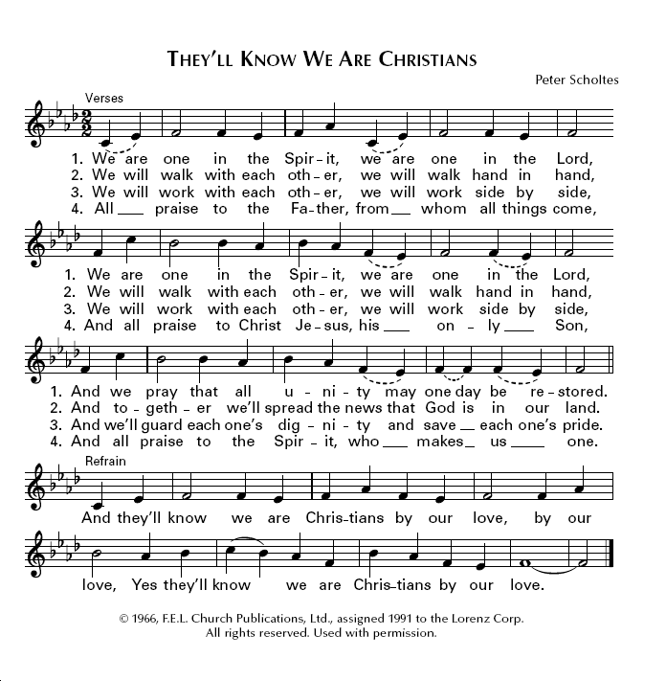

Introduction:

A proven fact is that military and political solutions do not bring peace.

In our quest to seek truth, make peace and reverence life should we strive to be peacemakers? Or should we be peace?

The refrain, LET THERE BE PEACE ON EARTH, AND LET IT BEGIN WITH ME, is the basis of this prayer and invitation.

As each becomes more and more “peace” the power for bringing about peace is spreading like the ripples of a pebble thrown into the ocean.
Readers:
- Deliver me oh God, from the exploitation of fear to justify any means and cruelty.
- Deliver me from collective phobias fed by political agendas to see others as evil.
- Deliver me from subversive arguments that classify contrary ideas and beliefs as equal to “crazy” to justify taking control over them.
- Deliver me from my intolerance which blinds, my judgments which divide.
- Deliver me from my own dark side, my anger, jealously, my competitiveness instead of cooperation, self interest, self image, my ego.
- Deliver me from toxic nationalism, false patriotism and all the images that trap my spirit.

Moment of Silent Reflection:
Leader: Oh merciful and loving God,
Left: Forgive me for failing to think for myself, for taking the course of
least resistance and siding with those who think like I do and not
listening to others.
Right: Forgive me for not seeking truth.
Left: Forgive me for being so comfortable in my privileged, secure status as
a religious.
Right: Forgive me for not recognizing and accepting my responsibility for
peace, first of all in me.

Closing Prayer: All

God in your mercy to all humanity, you take no sides in conflict. You cherish and understand how often I lose touch and become separated from the peace which you want to bring me, which is connection with you, my source, and my brothers and sisters, help me to cherish myself with patience, constancy and renewed trust in what is real, what is truth.

PAUSE FOR A MOMENT OF REFLECTION

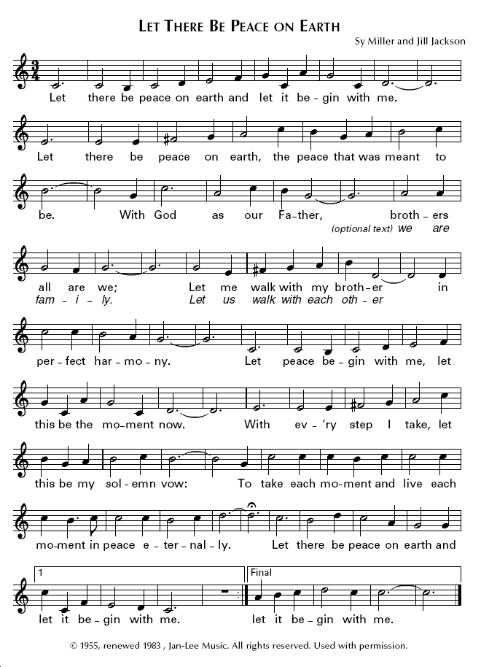
Prayer: Oh God, Your essence is pure love and consciousness, your
presence is constant, manifested in each soul, regardless of any
circumstance.

Left: Expand my consciousness and awareness by increasing my belief
that PEACE IS POSSIBLE, and love is the energy to unite with all
to make it happen.

Right: Let your compassion for victims of war and injustice fill me with a
force to create change in me.

Left: Help me to envision a new world order of peace and make the
positive and creative intentions from the depth of my being to
bring it about in me.

Right: Lead me to establish peace in each and every one of my
relationships because world peace comes one individual at a time.

Left: Increase my consciousness of the rays of light, however small, of
the breakthroughs, of the way more and more people are involved
in the peace movement, one individual at a time increasing hope.

Hum: Let there be peace on earth
Take a few moments to reflect on the following concepts.

Read in Silence:
Oh God,
- Let me see, not the “enemy” but another human being made to your image.
- Let me see the labeling of other human beings for what it is: dehumanization so I do not have to relate to them.
- Let me see the minimization of the atrocities on “our” side and the disproportional exaggerations of suspected or proven abuse on “their” side.
- Let me see the evil in me instead of projecting it to the evil in “them”.
